UMS makes it possible for University of Michigan student singers to attend inspiring performances from amazing talent such as the King’s Singers. Please support the students who comprise the a cappella groups at the University by attending their upcoming performance:



12 student a cappella groups present an unforgettable evening of entertainment for all ages!

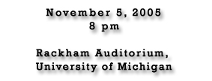

Tickets are $10 and directly benefit student performers

For more information regarding U of M a cappella groups, please visit the Michigan A Cappella Council Website:

http://www.umich.edu/~umsing

The Michigan A Cappella Council, run by a board of student leaders, in conjunction with Arts at Michigan, serves the campus a cappella community by providing resources and producing collaborative performances.

